Dear FOCUS Parents,
We will be completing our unit studying The Physics of Flight in a few weeks. As a culminating activity we will be participating in some exciting flight activities. One of these is a simulated flight, and for our “in flight movie” we will be showing Disney’s, Planes. The movie is rated PG. It has been viewed and approved by staff members as indicated by school protocol. Please sign below to give your child permission to watch the movie.
I am also asking for a few in flight refreshment donations. Please indicate below if you are willing to send in an item listed.
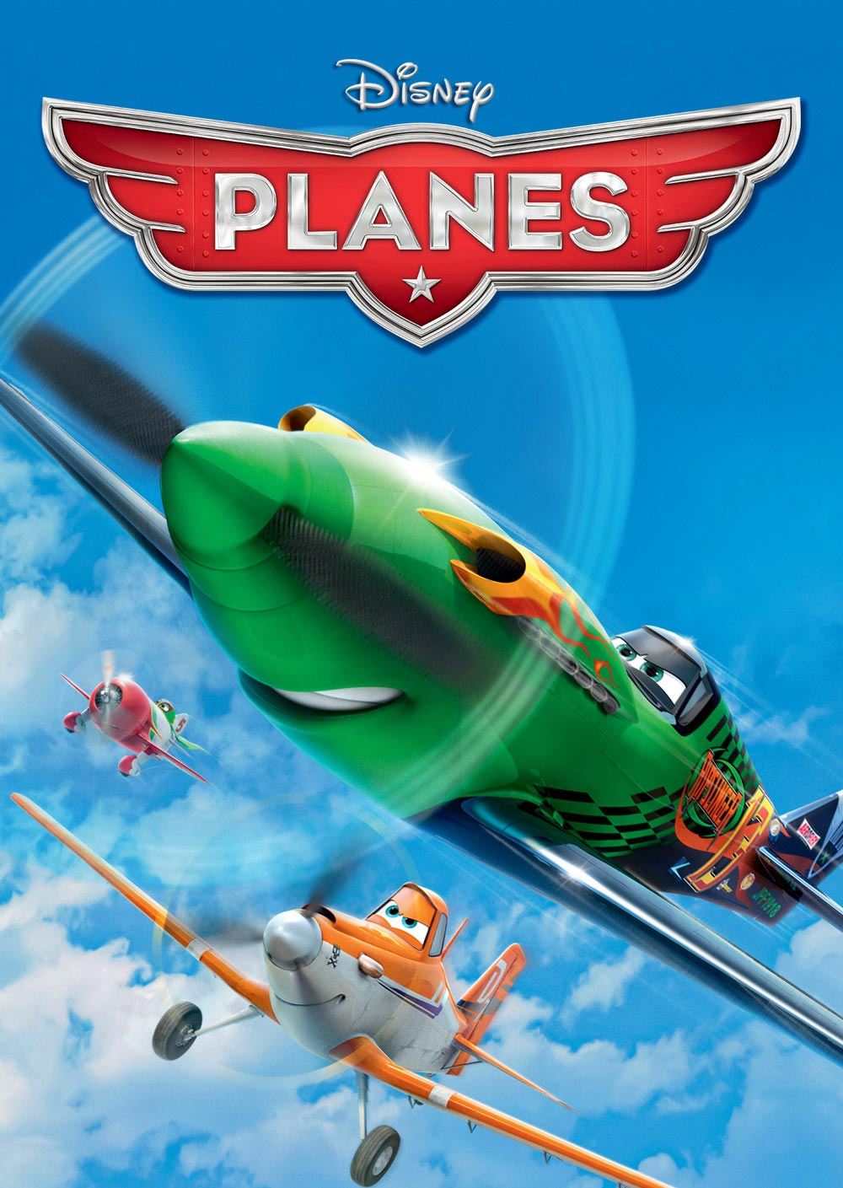

As always, thank you for your help and support!
Katrina Ferebee

---------------------------------------------------------------------------
By signing below I give my child permission to watch Disney’s Planes.
Child’s Name _________________________________________
Parent Signature ______________________________________
I will donate (circle one): Send in by 3-31-14
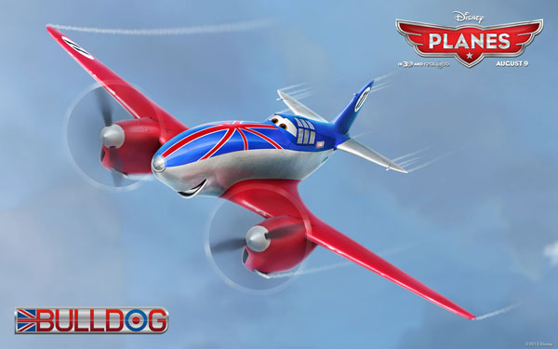
Juice boxes
Pretzels
Cookies

